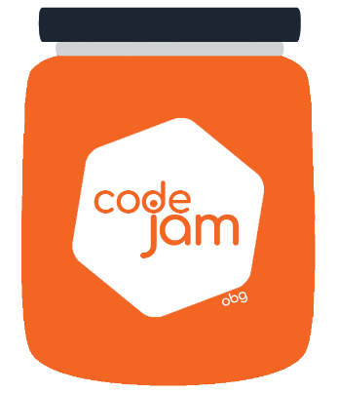

Challenge 3: Pimp your Dog

Dog DONE you are fairly confident that this the end. You pack up your stuff and you are ready to leave when, yet again our beloved PO comes with a fairly strange face. He was told that the head designer of the brand saw the results and was not happy and the brand asked for some more changes. The specs were too vague to make any sense so you start unpacking yet again to code a bit more…. a bit more….

What you need to do:

1. Time to complete is 30min
2. Each team member has 10min to code.
3. The rest of the team can assist without coding (helping, giving ideas).
4. You can create with CSS and/or JS **any enhancements** that accompanies and makes your dog more beautiful, **be creative**.
5. There has to be **a dog tag with the team name**.
6. In case the dog was not complete you can complete it in the given time.
7. You should not use any libraries to do the enhancements and they should be done with Pure CSS / Vanilla JS